**REAL TIME RIVER WATER QUALITY MONITORING AND CONTROL SYSTEM**

**(INTERNET of THINGS)**

## In fulfillment of project in IBM-NALAYATHIRAN 2022

**SUBMITTED BY**

**TEAM ID : PNT2022TMID14744**

|  |  |
| --- | --- |
| **SARAVANAN C** | **111619106126** |
| **SHARUN KRISHNAN** | **111619106131** |
| **SIDHESH** | **111619106133** |
| **DHANASEKAR**  **YARRAPOTHU CHARAN** | **111619106027**  **111619106157** |

**BACHELOR OF ENGINEERING IN**

**ELECTRONICS AND COMMUNICATION ENGINEERING**

## R.M.K COLLEGE OF ENGINEERING AND TECHNOLOGY,

**Puduvoyal , Thiruvallur , TamilNadu-601 206**

INDEX

1. **INTRODUCTION**
   1. **Project Overview**
   2. **Purpose 2.LITERATURE SURVEY**
   3. **Existing problem**
   4. **References**
   5. **Problem Statement Definition 3.IDEATION & PROPOSED SOLUTION**
   6. **Empathy Map Canvas**
   7. **Ideation & Brainstorming**
   8. **Proposed Solution**
   9. **Problem Solution fit 4.REQUIREMENT ANALYSIS**
   10. **Functional requirement**
   11. **Non-Functional requirements 5.PROJECT DESIGN**
   12. **Data Flow Diagrams**
   13. **Solution & Technical Architecture**
   14. **User Stories**
2. **PROJECT PLANNING & SCHEDULING**
   1. **Sprint Planning & Estimation**
   2. **Sprint Delivery Schedule 7.CODING & SOLUTIONING**
   3. **Node Red service associated with IBM Cloud**
   4. **MIT App service Receive data from IBM cloud 8.TESTING**
   5. **Test Cases**
   6. **User Acceptance Testing 9.RESULTS**

**9.1 Performance Metrics 10.ADVANTAGES & DISADVANTAGES 11.CONCLUSION**

1. **FUTURE SCOPE**
2. **APPENDIX**
   1. **Source Code**
   2. **GitHub & Project Demo Link**
   3. **Project Overview**:
3. INTRODUCTION

*River Water quality monitoring System*

River water which is used as drinking water is a very precious commodity for all human beings. The system consists of several sensors which are used for measuring physical and chemical parameters of water. The parameters such as temperature, pH, and dissolved oxygen of the water can be measured. Using this system a person can detect pollutants from a water body from anywhere in the world Current water quality monitoring system is a manual system with a monotonous process and is very time- consuming This paper proposes a sensor based water quality monitoring system. The main components of Wireless Sensor Network (WSN) include a micro-controller for processing the system, communication system for inter and intra node communication and several sensors Real-time data access can be done by using remote monitoring and Internet of Things (IoT) technology Data collected at the IBM cloud Server and verify them to trigger the actions to be performed.

* 1. **Purpose:**

Water quality refers to chemical, physical biological and radio logical characteristics of water. It is a measure of the condition of water relative to the necessities of one or more bio-tic species and or to any human need or purposes. Water quality monitoring is defined as a sampling and analysis of the water in lake, stream, ocean and river and conditions of the water body. Smart water quality monitoring is a process of real-time monitoring and the analysis of water to identify changes in parameters based on the physical, chemical and biological characteristics. Monitoring water quality is clearly important: in our seas, our rivers, on the surface and in our ports, for both companies and the public. It enables us to assess how they are changing, analyze trends and to inform plans and strategies that improve water quality and ensures that water meets its designated use.

There are several indicators determining water quality. These include dissolved oxygen, turbidity, bio indicators, nitrates, pH scale and water temperature. Monitoring water quality helps to identify specific pollutants, a certain chemical, and the source of the pollution. There are many sources of water pollution: wastewater from sewage seeping into the water supply; agricultural practices (e.g., the use of pesticides and fertilizer); oil pollution, river and marine dumping, port, shipping and industrial activity. Monitoring water quality and a water quality assessment regularly provides a source of data identify immediate issues – and their source.

* + - Identifying trends, short and long-term, in water quality.
    - Data collected over a period of time will show trends, for example identifying increasing concentrations of nitrogen pollution in a river or an inland waterway. The total data will then help to identify key water quality parameters.
    - Environmental planning methods: water pollution prevention and management.
    - Collecting, interpreting and using data is essential for the development of a sound and effective water quality strategy. The absence of real-time data will however hamper the development of strategies and limit the impact on pollution control. Using digital systems and programs for data collection and management is a solution to this challenge.

Monitoring water quality is a global issue and concern: on land and at sea. Within the European Union, the European Green Deal sets out goals for restoring biological biodiversity and reducing water pollution, as well as publishing various directives to ensure standards of water quality. Individual nation states, for example France, have also clear regulatory frameworks requiring the effective monitoring of water quality. In the United States, the Environmental Protection Agency (EPA) enforces regulations to address water pollution in each state. Across the world, countries increasingly understand the importance of effective water quality monitoring parameters and methods.

# LITERATURE SURVEY

## Existing Problem:

Due to population growth, urbanization, and climatic change , competition for water resources is expected to increase, with a particular impact on agriculture, river water. Water will be suitableness to potable water monitoring compound spillage identification done rivers, remote estimation for swimming pools. It holds self- sufficient hubs that unite with the cloud to ongoing water control .The River water needed to be treated before it is used in agriculture fields, hence the parameters affecting the quality of river-water need to be analyzed and to be

used for water treatment purpose.

## References:

1. K.S. Adu-Manu, C. Tapparello, W. Heinzelman, F.A. Katsriku, J.-D. Abdulai

**Water quality monitoring using wireless sensor networks:** Current trends and future research directions ACM Transactions on Sensor Networks (TOSN) (2017).

1. S. Thombre, R.U. Islam, K. Andersson, M.S. Hossain

*IP based Wireless Sensor Networks : performance Analysis using Simulations and*

**Experiments.** Journal of Wireless Mobile Networks, Ubiquitous Computing, and Dependable Applications, 7 (2016).

1. Rushikesh Kshirsagar, R.Mudhalwadkar, Saish Kalaskar

**Design and Development of IoT Based Water Quality Measurement System.** The idea about low-cost IOT based portable approach for water quality measurements system. Because of its low-cost approach, everyone can afford to use it to determine quality of water(2019).

1. N. Vijayakumar, R. Ramya

**The real time monitoring of water quality in IoT environment.** The parameters such as temperature, PH, turbidity, conductivity, dissolved oxygen of the water can be measured. The measured values from the sensors can be processed by the core controller. The raspberry PI

B+ model can be used as a core controller (2015).

1. M.Chitra, D. Sadhihskumar, R. Aravindh, M. Murali, R. Vaittilingame

**IoT based Water Flood Detection and Early Warning System.** The collected information (data) from the water level sensor and temperature and humidity sensor passed to Thing view Android application in order to find the flow graph level of the water level in the river and temperature, humidity values and sends SMS to the registered contact mobile numbers (2020).

1. Dr.Geetha

*IoT based real time water quality monitoring system using smart sensor*

WQM is a cost effective and efficient system designed to monitor drinking water quality with the help of IOT(2020).

* 1. **Problem Statement:**

The reduce the river water pollution and to monitor the parameters of river water and control measures can impact vegetation, health. The Real time analysis of Indicators of River water (Ph, Temperature, Turbidity etc..,)

## IDEATION & PROPOSED SOLUTION

* 1. **Empathy Map Canvas:**

An empathy map is a simple, easy-to-digest visual that captures knowledge about a user’s behaviors and attitudes. It is a useful tool to helps teams better understand their users. Creating an effective solution requires understanding the true problem and the person who is experiencing it. The exercise of creating the map helps participants consider things from the user’s perspective along with his or her goals and challenges.

EMPATHY MAP

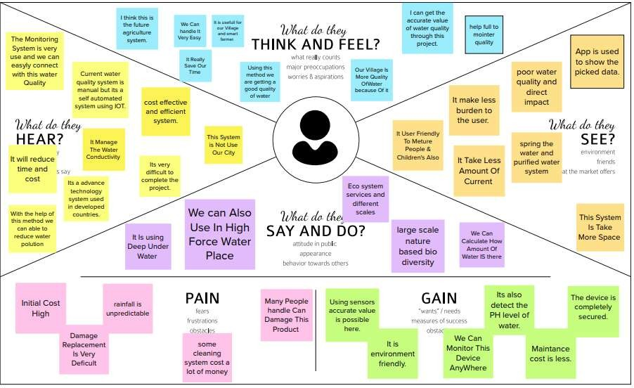

Project members;

1.111619106126 Saravanan

2.111619106131 Sharun Krishnan

3.111619106133 Sidhesh

4.111619106027 Dhanasekar

5.111619106157 Yarrapothu Charan

## Ideation & Brainstorming:

Brainstorming provides a free and open environment that encourages everyone within a team to participate in the creative thinking process that leads to problem solving. Prioritizing volume over value, out-of-the-box ideas are welcome and built upon, and all participants are encouraged to collaborate, helping each other develop a rich amount of creative solutions.

Use this template in your own brainstorming sessions so your team can unleash their imagination and start shaping concepts even if you're not sitting in the same room.

**Brainstorm & Idea Prioritization Template:**

**Step-1: Team Gathering, Collaboration and Select the Problem Statement**

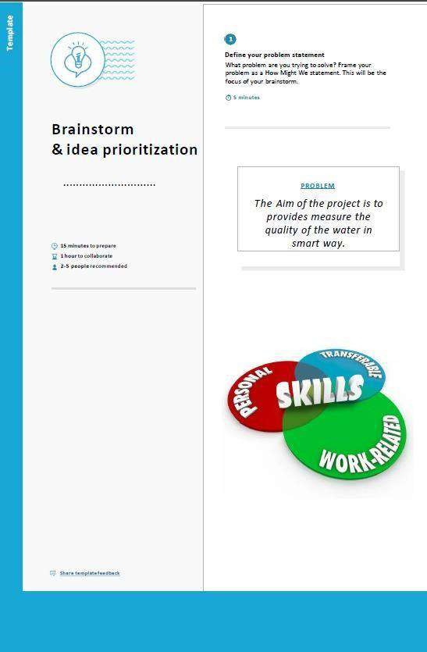

**Step-2: Brainstorm, Idea Listing and Grouping**

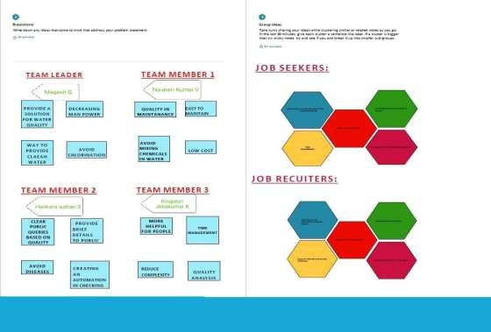

**Step-3: Idea Prioritization**

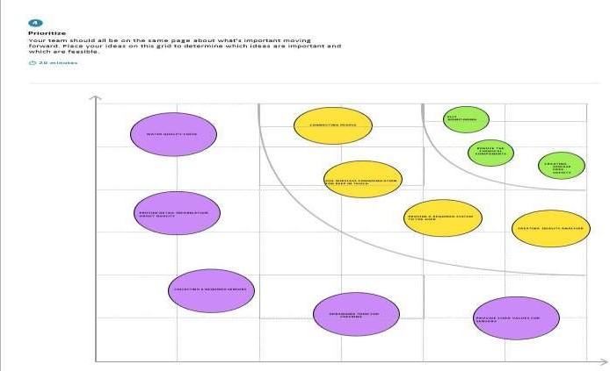

## Proposed Solution:

|  |  |  |
| --- | --- | --- |
| **Proposed Solution Template: S.No** | **Parameter** | **Description** |
| 1. | Problem Statement (Problem to be solved) | A water quality management system helps to check the quality of water which include temperature, humidity and pH in real time and more helpful for human resource. |
| 2. | Idea / Solution description | The idea for this project basically contain sensor for detection of water quality and provide pure water for  the public in good condition. |
| 3. | Novelty / Uniqueness | The uniqueness of the project is, it contain high quality sensor with high sensitivity and low cost with multiple use and it provide high quality water. |
| 4. | Social Impact / Customer Satisfaction | Even-though, it reduces the manpower it help more graduates to work on this project and people can more aware about the latest trends  and technologies. |
| 5. | Business Model (Revenue Model) | It is more profitable and simple model to manufacture. In business model it provide high revenue with low investment. |
| 6. | Scalability of the Solution | It can withstand over a long period of time, easily usable product and utilization of  more technologies. |

* 1. **PROBLEM SOLUľION:**

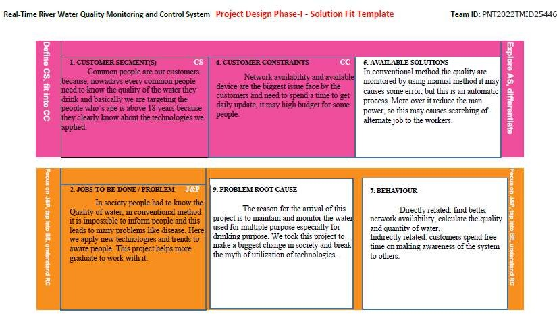

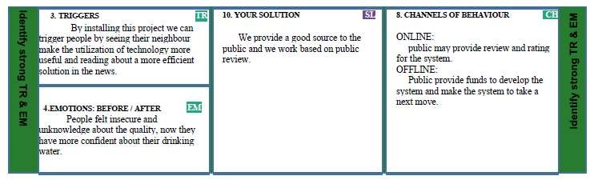

## REQUIREMENT ANALYSIS

* 1. **Functional Requirements*:***

Following are the functional requirements of the proposed solution

|  |  |  |
| --- | --- | --- |
| **FR No.** | **Functional Requirement (Epic)** | **Sub Requirement (Story / Sub-Task)** |
| FR-1 | User Registration | Registration through Form Registration through Gmail  Registration through LinkedIn |
| FR-2 | User Confirmation | Confirmation via Email Confirmation via OTP |
| FR-3 | Ph level detection | To observe the water quality, Ph sensor is used and the signals are conveyed to the Arduino. |
| FR-4 | Turbidity detection | Turbidity sensor measures the purity of element or marshy utter in the water and the signals are delivered to Arduino |

## Non-functional Requirements:

Following are the non-functional requirements of the proposed solution.

|  |  |  |
| --- | --- | --- |
| **FR No.** | **Non-Functional Requirement** | **Description** |
| NFR-1 | **Usability** | Monitors the flow and quality of ground water, and investigates surface- and ground-water interactions. |
| NFR-2 | **Security** | The data and information are secured in the application by using the application firewall. |
| NFR-3 | **Reliability** | The Real me sensor output values with future predicted data storage with output efficiency of 98%. It also gives certainty for aquaculture safety. |
| NFR-4 | **Performance** | The performance of system has higher efficiency and environmental friendly. |
| NFR-5 | **Availability** | It is available in the form of mobile UI 24 x 7 monitoring system. |
| NFR-6 | **Scalability** | The system has high scalability. Able to be changed in size or scale to give the best output. |

## PROJECT DESIGN

* 1. **Data Flow Diagrams:**

A Data Flow Diagram (DFD) is a traditional visual representation of the information flows within a system. A neat and clear DFD can depict the right amount of the system requirement graphically. It shows how data enters and leaves the system, what changes the information, and where data is stored.

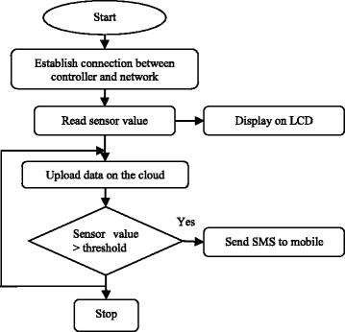

## SOLUTION AND TECHNICAL ARCHITECTURE:

**Summary**:

This code pattern explains how to build an IOT based river water monitoring and controlling system with some predefined values.

Flow

* + - Feed the data received from the Sensor unit which are placed in the river sides.
    - The collected data will be displayed in the Web page to the user.
    - Then the collected data is sent to the data base, where the collected data and the predefined data are checked and monitored.
    - If any data exceed the predefined data then the control signal will send to the Admin.
    - The collected data will be stored in the IBM cloud storage. Later the data will be controlled by the admin via Web UI.

**Table-1 : Components & Technologies:**

|  |  |  |  |
| --- | --- | --- | --- |
| **S.No** | **Component** | **Description** | **Technology** |
| 1. | User Interface | How user interacts with application e.g. Web UI, Mobile App, Chatbot etc. | HTML, CSS,  JavaScript / Angular Js / React Js etc. |
| 2. | Application Logic-1 | Logic for a process in the application | Python |
| 3. | Application Logic-2 | Logic for a process in the application | IBM Watson STT service |
| 4. | Application Logic-3 | Logic for a process in the application | IBM Watson Assistant |
| 5. | Database | Data Type, Configurations etc. | MySQL, NoSQL,  etc. |
| 6. | Cloud Database | Database Service on Cloud | IBM DB2, IBM  Cloudant etc. |

|  |  |  |  |
| --- | --- | --- | --- |
| 7. | File Storage | File storage requirements | IBM Block Storage or Other Storage  Service or Local Filesystem |
| 8. | External API-1 | Purpose of External API used in the application | IBM Weather API, etc. |
| 9. | External API-2 | Purpose of External API used in the application | Aadhar API, etc. |
| 10. | Machine Learning Model | Purpose of Machine Learning Model | Object Recognition Model, etc. |
| 11. | Infrastructure (Server  / Cloud) | Application Deployment on Local System / Cloud Local Server Configuration: Cloud Server  Configuration : | Local, Cloud Foundry, Kubernetes, etc. |

**Table-2: Application Characteristics:**

|  |  |  |  |
| --- | --- | --- | --- |
| **S.**  **No** | **Characteristics** | **Description** | **Technology** |
| 1. | Open-Source Frameworks | List the open-source frameworks used | Technology of Opensource framework |
| 2. | Security Implementations | List all the security / access controls implemented, use of firewalls etc. | e.g. SHA-256, Encryptions, IAM Controls, OWASP etc. |
| 3. | Scalable Architecture | Justify the scalability of architecture (3 – tier, Micro-services) | Technology used |
| 4. | Availability | Justify the availability of application (e.g. use of load balancers, distributed servers etc.) | Technology used |
| 5. | Performance | Design consideration for the performance of the application (number  of requests per sec, use of Cache, use of CDN’s) etc. | Technology used |

## User Stories:

|  |  |  |  |  |  |  |  |  |  |  |  |  |  |  |  |  |  |
| --- | --- | --- | --- | --- | --- | --- | --- | --- | --- | --- | --- | --- | --- | --- | --- | --- | --- |
| **User Type** | **Functional Requiremen**  **t (Epic)** | | | | **User Story Number** | | | **User Story / Task** | | **Acceptance criteria** | | | **Priority** | | | | **Release** |
| Customer (Mobile user) | Registration | | | | USN-1 | | | As a user, I can register for the application by entering my email, password, and confirming  my password. | | I can access my account / dashboard | | | High | | | | Sprint-1 |
| USN-2 | | | As a user, I will receive confirmation email once I have registered for the application | | | | I can receive confirmation email & click confirm | | | | High | | | | Sprint-1 | | |
| USN-3 | | | As a user, I can register for the application through  Facebook | | | | I can register & access the dashboard with  Facebook Login | | | | Low | | | | Sprint-2 | | |
| USN-4 | | | | As a user, I can register for the application through Gmail | | | | | Medium | | | | | Sprint-1 | | | |
| Login | | | USN-5 | | | | As a user, I can log into the application by entering email &  password | | | | High | | | | Sprint-1 | | |
| Dashboard | | | | | | USN-6 | | | | | | As a user I can login to the dashboard and search the access account and receive mail. | | | | | |
| Customer (Web user) | | Login | | | | UI | | | As a user I need to create an account by providing all the necessary  information. | | | Medium | | | | Sprint - 1 | |
| Customer Care Executive | Registration | | | | UX | | | As a customer I need register for the care executive for the  application | | I can register and access the account | | | High | | | | Sprint - 1 |
| Administrator | | | Confirmation | | | | As a customer confirmation mail once registered for  the web user | | | | High | | | | Sprint - 1 | | |

* 1. **PROJECT PLANNING AND SCHEDULING**
  2. **SPRINT PLANNING & SCHEDULING:**

|  |  |  |
| --- | --- | --- |
| **TITLE** | **DESCRIPTION** | **DATE** |
| **Literature Survey & Informa on Gathering** | Literature survey on the selected project is done by  gathering information about related details on technical papers and web browsing. | 06  OCTOBER 2022 |
| **Empathy Map** | Prepared Empathy Map Canvas to combine thoughts and pains, gains of the project with all team members . | 08  OCTOBER 2022 |
| **Ideation** | Brainstorming session is conducted with all team members to list out all the ideas and priori se the top 3  ideas. | 09  OCTOBER 2022 |
| **Proposed Solution** | Prepared the proposed solution document, which includes the novelty, feasibility of idea, business model, social impact, scalability of solution, etc. | 28  OCTOBER 2022 |
| **Problem Solution Fit** | Prepared problem - solution fit document. | 30  OCTOBER 2022 |

* 1. **SPRINT DELIVERY SCHEDULE**:

|  |  |  |  |  |  |  |
| --- | --- | --- | --- | --- | --- | --- |
| **Sprint** | **Functional Requirement (Epic)** | **User story Numb err** | **User Story / Task** | **Story Points** | **Priority** | **Team Members** |
| Sprint-1 | Registration | USN-1 | As a user, I can register for the application by entering my email, password, and confirming My password. | 2 | High | Saravanan,  Sharun Krishnan,  Sidhesh,  Dhanasekar,  Yarrapothu Charan |
| Registration via Facebook | USN-3 | As a user, I can register for the application through  Facebook | 2 | Low |
| Registration via Mail ID | USN-4 | As a user, I can register for the application through Gmail | 2 | Medium |
| Sprint-2 | Confirmation | USN-2 | As a user, I will receive confirmation email onceI have registered for the application | 1 | High |
| Login | USN-5 | As a user, I can log into the application by entering email & password | 1 | High |
|  | IBM Cloud service Access | Get access to IBM cloud services. | 2 | High |
| Sprint-3 | Create the IBM Watson IoT and device Settings | USN-6 | To create the IBM Watson IoT Platform and integrate the microcontroller with it, to send the sensed data on Cloud | 2 | High | Saravanan,  Sharun Krishnan,  Sidhesh,  Dhanasekar,  Yarrapothu Charan |
| Create a node red service | USN-7 | To create a node red service to integrate the IBM Watson along with the Web UI | 2 | medium | Saravanan,  Sharun Krishnan,  Sidhesh,  Dhanasekar,  Yarrapothu Charan |
| Create a Web UI | USN-8 | To create a Web UI, to access the data from the cloud And display all parameters. | 2 | Medium | Saravanan,  Sharun Krishnan,  Sidhesh,  Dhanasekar,  Yarrapothu Charan |
| To develop a Python code | USN-9 | Create a python code to sense the physical quantity And store data. | 2 | Medium | Saravanan,  Sharun Krishnan,  Sidhesh,  Dhanasekar,  Yarrapothu Charan |

|  |  |  |  |  |  |
| --- | --- | --- | --- | --- | --- |
| Publish Data to cloud. | USN- 10 | Publish Data that is sensed by the microcontroller to the Cloud | 3 | High | Saravanan,  Sharun Krishnan,  Sidhesh,  Dhanasekar,  Yarrapothu Charan |
| Fast-SMS Service | USN- 11 | Use Fast SMS to send alert messages once the parameters like pH, Turbidity and temperature goes beyond the threshold | 3 | High | Saravanan,  Sharun Krishnan,  Sidhesh,  Dhanasekar,  Yarrapothu Charan |
| Testing | USN- 12 | Testing of project and final deliverables | 3 | Medium |

**Project Tracker, Velocity & Burn down Chart:**

|  |  |  |  |  |  |  |
| --- | --- | --- | --- | --- | --- | --- |
| **Sprint** | **Total Story Points** | **Duration** | **Sprint Start Date** | **Sprint End Date(Planned)** | **Story Points Completed (as on Planned**  **End Date)** | **Sprint Release Date (Actual)** |
| Sprint-1 | 20 | 4 Days | 24 Oct  2022 | 27 Oct 2022 | 20 | 29 Oct 2022 |
| Sprint-2 | 20 | 5 Days | 28 Oct  2022 | 01 Nov 2022 | 20 | 04 Nov 2022 |
| Sprint-3 | 20 | 8 Days | 02 Nov  2022 | 09 Nov 2022 | 20 | 11 Nov 2022 |
| Sprint-4 | 20 | 9 Days | 10 Nov  2022 | 18 Nov 2022 | 20 | 19 Nov 2022 |

**Velocity:**

Imagine we have 10-day sprint duration, and the velocity of the team is 20 (points per sprint). Let’s calculate the team’s average velocity (AV) per iteration unit (story points per day)



**Burndown Chart:**

A burn down chart is a graphical representation of work left to do versus time. It is often used in agile [software development m](https://www.visual-paradigm.com/scrum/what-is-agile-software-development/)ethodologies such as [Scrum.](https://www.visual-paradigm.com/scrum/scrum-in-3-minutes/) However, burn down charts can be applied to any project containing measurable progress over time.

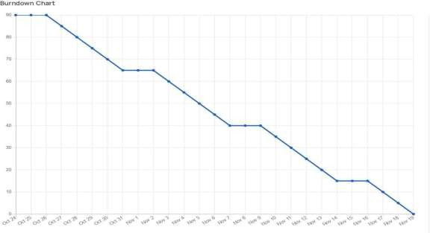

## CODING AND SOLUTIONING

* 1. **NODE RED SERVICE ASSOCIATED WITH IBM CLOUD:**

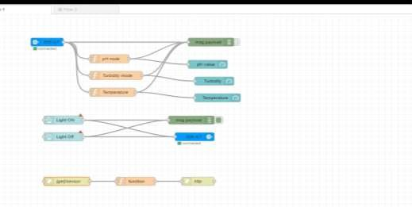

**Node red Dashboard:**

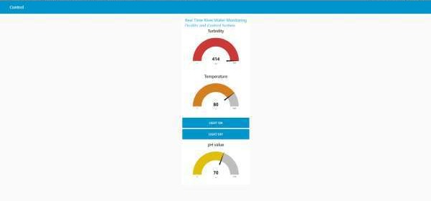

## MIT App service Receive data from IBM cloud:

**MOBILE APP USING MIT APP INVENTOR**

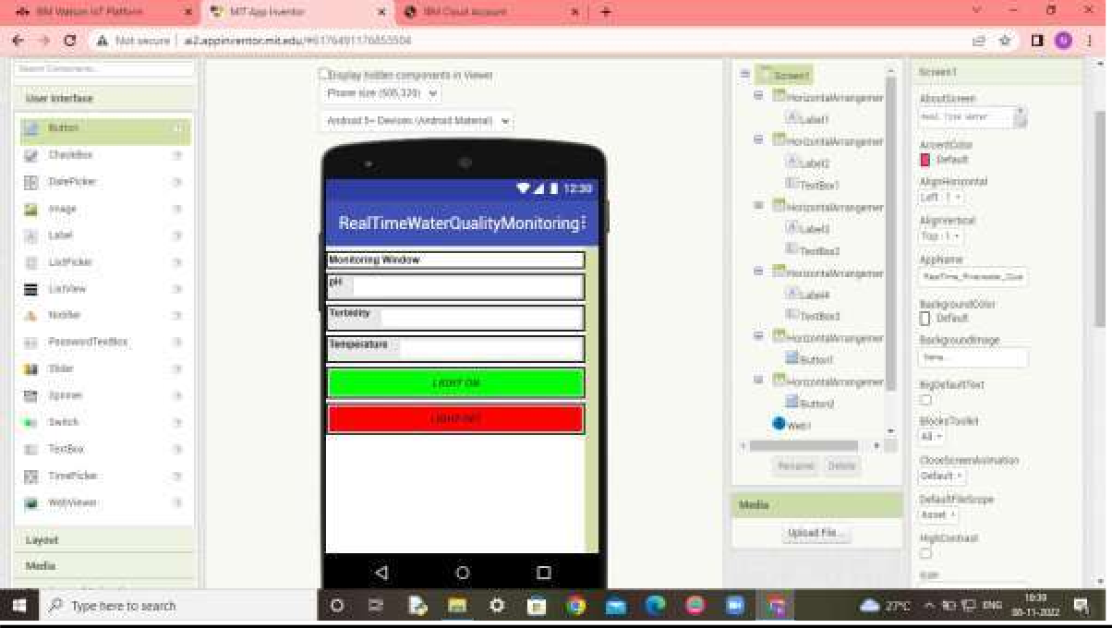

**MOBILE APP RECEIVE DATA FROM CLOUD**

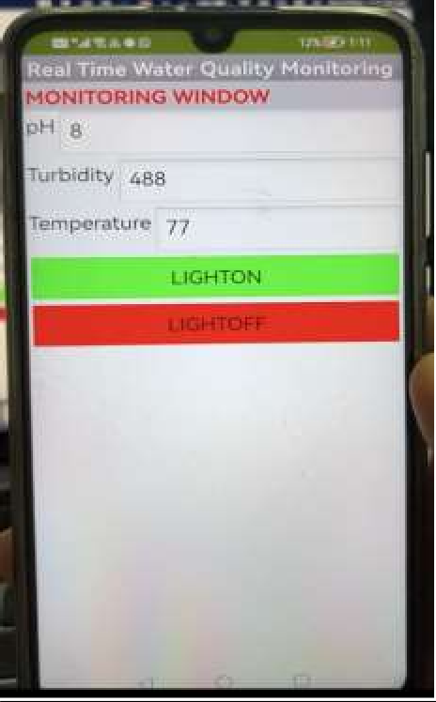

* 1. **TESTING**

# Test Case Analysis:

This report shows the number of test cases that have passed, failed, and untested

|  |  |  |  |  |
| --- | --- | --- | --- | --- |
| **Section** | **Total Cases** | **Not Tested** | **Fail** | **Pass** |
| Print Engine | 10 | 0 | 0 | 10 |
| Client Application | 35 | 0 | 0 | 35 |
| Security | 1 | 0 | 0 | 1 |
| Outsource Shipping | 2 | 0 | 0 | 2 |
| Exception Reporting | 10 | 0 | 0 | 10 |
| Final Report Output | 4 | 0 | 0 | 4 |
| Version Control | 3 | 0 | 0 | **3** |

## USER ACCEPTANCE TESTING:

1. **Purpose of Document:**

The purpose of this document is to briefly explain the test coverage and open issues of the REAL TIME RIVER WATER QUALITY MONITORING AND

CONTROL SYSTEMS project at the time of the release to User Acceptance Testing (UAT).

1. Defect Analysis *:*

This report shows the number of resolved or closed bugs at each severity level, and how they were resolved

|  |  |  |  |  |  |
| --- | --- | --- | --- | --- | --- |
| **Resolution** | **Severity 1** | **Severity 2** | **Severity 3** | **Severity 4** | **Subtotal** |
| By Design | 8 | 5 | 4 | 3 | 20 |
| Duplicate | 2 | 0 | 2 | 0 | 4 |
| External | 3 | 4 | 1 | 2 | 10 |
| Fixed | 10 | 1 | 5 | 14 | 30 |
| Not Reproduced | 0 | 0 | 1 | 0 | 1 |
| Skipped | 0 | 0 | 1 | 1 | 2 |
| Won't Fix | 0 | 1 | 2 | 1 | 4 |
| Totals | 23 | 11 | 16 | 21 | 71 |

## RESULT

* 1. **PERFROMANCE METRICS:**

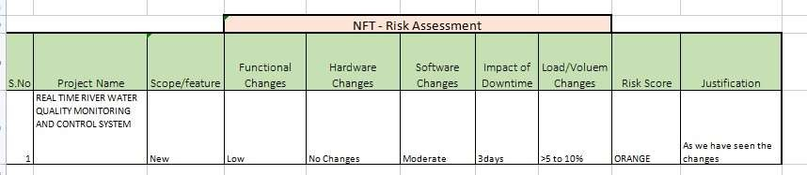

**PERFORMANCE TABLE:**

|  |  |  |
| --- | --- | --- |
| PARAMETER | PERFORMANCE | DESCRIPTION |
| ADMIN TESTING | 95%-100% | THE TESTING DONE BEFORE IT IS  DEPLOYED AS AN APP |
| CUSTOMER | 75-85% | THE CUSTOMER NEED |
| SATISFACTION |  | TO BE SATISFIED WITH |
|  |  | THE MOBILE |
|  |  | APPLICATION |
| USER INTERFACE | 65-85% | THE APP CAN USED BY ANYONE. (EASY OF  ACCESS) |
| SEVER RESPONSE | 50-75% | URL – response |
| DATA VALIDATION | 60-80% | VALID DATA FROM THE |
| WITH NO. OF TEST | (15-30 | APP |
| CASE | TESTCASE) |  |
| ERROR | 3-5% | REAL-TIME DELAY MAY OCCUR |

## ADVANTAGES AND DISADVANTAGES

**ADVANTAGES:**

* + - The prototype developed for water quality maintenance is very beneficial for safeguarding public health and also adds to the clean environment.
    - The automation of this water monitoring, cleaning and control process removes the need of manual labor and thus saves time and money.
    - The automation of the system makes the control and monitoring process more efficient and effective. Real time monitoring on mobile phone which is possible through the interface of plc with Arduino and Bluetooth module

allows remote controlling of the system.

**DISADVANTAGES:**

* + - It is difficult to collect the water samples from all the area of the water body.
    - The cost of analysis is very high.
    - The lab testing and analysis takes some time and hence the lab results does not reflect real time water quality measurement due to delay in measurement.
    - The process is time consuming due to slow process of manual data collection from different locations of the water body.
    - The method is prone to human errors of various forms.

## CONCLUSION

Thus our project is used to Monitoring of Turbidity, PH & Temperature of Water makes use of water detection sensor with unique advantage and existing GSM network. The system can monitor water quality automatically, and it is low in cost and does not require people on duty. So the water quality testing is likely to be more economical, convenient and fast. The system has good flexibility. Only by replacing the corresponding sensors and changing the relevant software programs, this system can be used to monitor other water quality parameters.

The operation is simple. The system can be expanded to monitor hydrologic, air pollution, industrial and agricultural production and so on. It has widespread application and extension value. By keeping the embedded devices in the environment for monitoring enables self protection (i.e., smart environment) to the environment. To implement this need to deploy the sensor devices in the environment for collecting the data and analysis. By deploying sensor devices in the environment, we can bring the environment into real life i.e. it can interact with other objects through the network.

Then the collected data and analysis results will be available to the end user through the Wi-Fi.

## FUTURE SCOPE

We use water detection sensor has unique advantage. It consumes less time to monitor than a manual method for checking polluted levels, and notifies immediately to reduce affected rate of pollution in water. People who are living in rural areas near to the river will be very satisfied with our idea.

It will be useful to monitor water pollution in specific area. So this system prevent people from water pollution. It will be used for farming purpose to check quality water, temperature and PH level. Our Impact of this project is also create a social satisfaction for farmers too. The scalability of this project gives the addition of more different type of sensors. By interfacing the relay we can control the supply of water.

We can also implement as a revenue model. This system could also be implemented in various industrial processes. The system can be modified according to the needs of the user and can be implemented along with lab view to monitor data on computers.

## APPENDIX

* 1. **SOURCE CODE:**

**PYTHON CODE TO PUBLISH DATA** :

Importibmiotf.application import ibmiotf.device import time

import random import sys

from twilio.rest import Client import keys

Client = Client(keys.account_sid, keys.auth_token) 0rganization ID

pnco2k Device Type

watermonitoringsystem Device ID watermonitoringsystemid Authentication Method use-token-auth Authentication Token y1KKoQTKx?i@jA&q9R

pH = random.randint(1, 14) turbidity = random.randint(1, 1000)

temperature = random.randint(0, 100) def myCommandCallback(cmd):

print("Command Received: %s" % cmd.data['command']) print(cmd)

try:

deviceOptions = {"org": organization, "type": deviceType, "id": deviceId, "authmethod":

authMethod,

"auth-token": authToken}

deviceCli = ibmiotf.device.Client(deviceOptions) except Exception as e:

print("caught exception connecting device: %s" % str(e)) sys.exit()

deviceCli.connect() while True:

pH = random.randint(1, 14)

turbidity = random.randint(1, 1000) temperature = random.randint(0, 100)

data = {'pH': pH, 'turbid': turbidity, 'temp': temperature} def myOnPublishCallback():

print("Published pH= %s" % pH, "Turbidity:%s" % turbidity, "Temperature:%s" %

temperature)

success = deviceCli.publishEvent("demo", "json", data, qos=0, on_publish=myOnPublishCallback)

if not success:

print("Not Connected to ibmiot") time.sleep(1)

deviceCli.commandCallback = myCommandCallback deviceCli.disconnect()

OUTPUT:

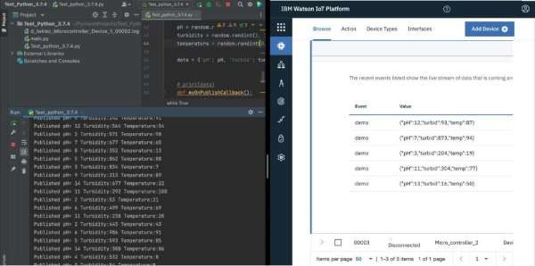

**WEB APP UI using Node Red:**



**OUTPUT:**

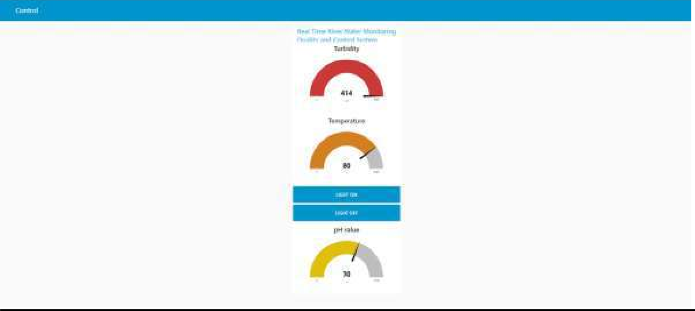

**MIT Mobile APP:**

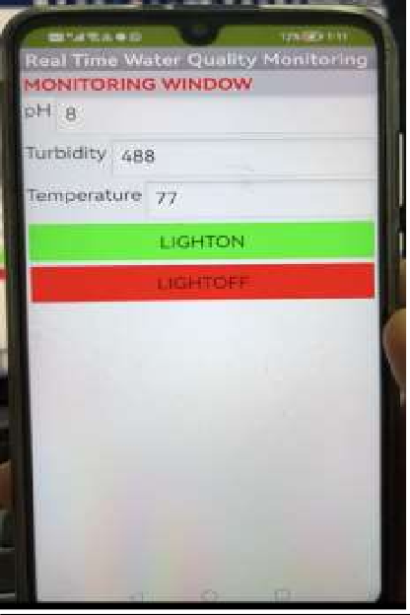

* 1. **GIT-HUB LINK:**

https://github.com/IBM-EPBL/IBM-Project-31140-1660196719

1. Final project video link:

[**IBM Final Demo Video**](https://drive.google.com/file/d/1kFpTwXf-CcMKhCUcLjl8XfCdcEtTAUjW/view?usp=drivesdk)

https://drive.google.com/file/d/1FmYKzTMe4CibX_gT5D4Bw5xidPU9a6Fm/view?usp=sharing